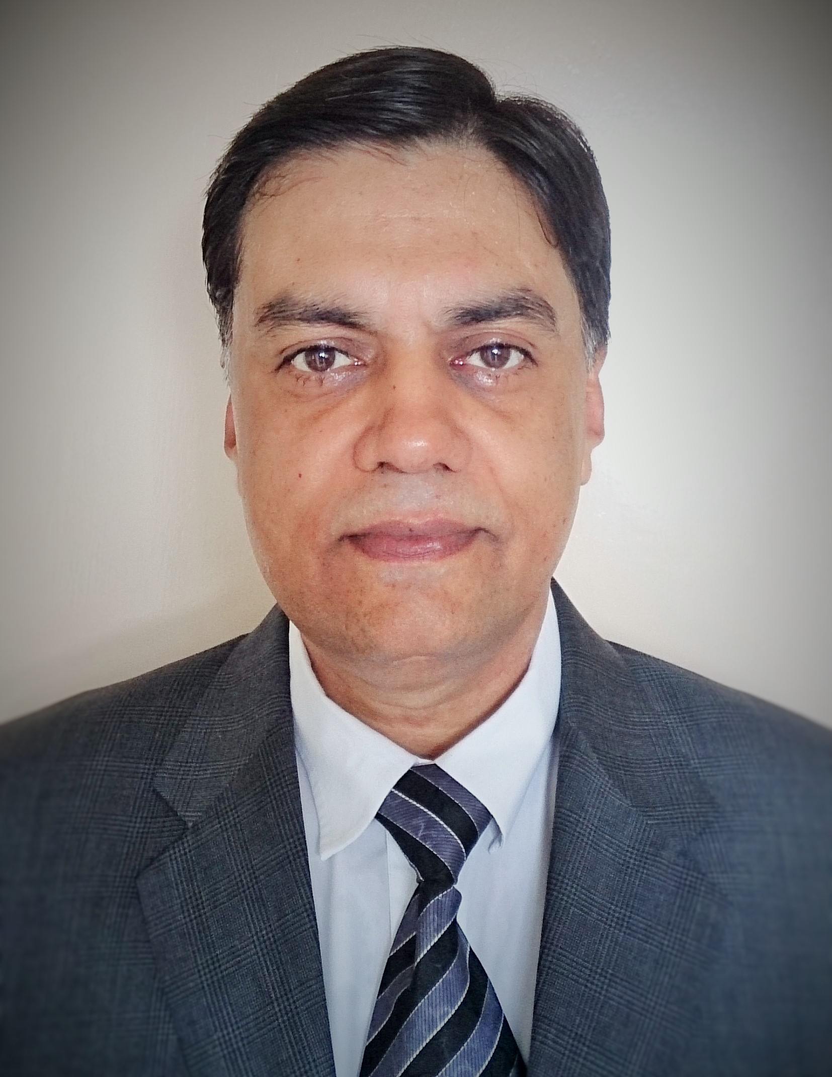
Madan Mehta

ADDRESS : # 408, Vardhaman Apartment,
Near Maharashtra Bhavan,
Bhupalpura,
Udaipur – 313001
CONTACT NO. : 09414238991
HOME : 07597911640
E-MAIL : madanmehta@ymail.com

SBU-HEAD-OPERATIONS/MARKETING/SENIOR MANAGEMENT

Over 25+ years of accomplished experience of field including Overseas Operations, Import, Export, Sales, Service, Marketing, Logistics, Consultancy, Liasioning, Procurement & Planning.

CAREER OBJECTIVE

Seeking Senior Level management assignments in SBU-Head Operations/Marketing/Management position with a dynamic organization preferably in National/International Business Unit that will help me cultivate and nurture my skills to the fullest with an opportunity to display my talent and become an asset to the organization.

PROFILE & STRENGTHS

- Competent professional with excellent negotiation skills and thorough knowledge of rate contracts.
- Possess requisite competence to forecast and document requirement of Materials.
- Meticulous professional, with high caliber and work orientation with proven ability to handle multiple functions and activities in a high pressure environment due to inherent ability to identify and prioritize tasks at hand.
- Successful track record for excellence, resource, initiative and leadership, which has enabled me to acquit myself with honors in a variety of key positions and capacities in the course of my career.
- Possess an extensive knowledge base and exceptional talent for problem solving through analytical thought processes, as well as the ability to build and lead effective teams.
- Articulate communicator with strong analytical and communication skills.
- Exhibits an ideal balance between Logistics and Finance Functions with rich domain knowledge in Management. Independently handled the Production facility as an additional charge of Group Company.

Core competencies include:

• SBU-Heead Operations, Senior Management • Marketing • Logistical Support • Supply Chain Management • Strategic Planning / Liaison / Coordination • Procurement / Sourcing • Analytical / Negotiation Skills • Versatile Leadership, Resource Management • Materials / Inventory Management • Project Management • Oversees operations.
PROFESSIONAL EXPERIENCE AND ACCOMPLISHMENTS

5

- Current Job: Since Jan’11 at Rajesh Motors Group

About Group: The group in its current avatar is having multifarious activities, which includes Automobiles & Earthmoving Dealerships, Construction, Mining, Transportation, Body Building, Finance etc. having turnover of over Rs. 1500 Crores.

The group is having dealerships of:

- Ashok Leyland products for Rajasthan & part of Maharashtra (Kolhapur, Sangli, Satara)
- JCB products for almost entire Rajasthan & stands at 5th position in world.
- General Motors (I) Ltd, for Large Part of Rajasthan
- Volkswagen India Ltd. For Udaipur Division
- Hyva Products for Rajasthan

Culture of customer satisfaction & Quality service in the Organization has led to a Positive & Sturdy business growth in last 50 years approx. Having Best Market share of products handled supported by the right Investments & Infrastructure Network in Rajasthan.

Supported by a Devoted and trained family of over 1300 members. The group has a culture of driving ownership amongst the members through empowerment, team work and providing right incentives in line with profit sharing.
Designation: SBU-Head as a GM

Job Responsibilities: As a General Manager handling total operations of Chevrolet product range & assisting the management in Group policy making process.

- From April’09 to Dec’10 at Graphic Systems (U) Ltd., Uganda

About Group: It is a flagship company of Multi million Dollar Graphic Group having interests in the field of printing industry. This company is pioneer in the field in the entire East Africa region for their continuous innovative & unique products in the industry. The Group has business interests in Canada, Angola and DRC in a variety of fields including manufacturing, services, trading and property. The business interests are all professionally managed and include a vast diversity such as agencies of Fuchs and Fuji products, an ice cream manufacturing plant, Coffee Processing & Franchisee holder for Vodocom.

Designation: Based at Kampala & Heading Marketing & Sales for Telecom, Insurance, Commercial, Hotel & other segments.

Job Responsibilities & Achievements:

- ERP based operations.
- Develop the breed of marketers from grass root level.
- Motivation of team regularly.

3. From Aug’08 to March’09 at Gravita India Ltd.

About Group: It is a fast growing 500 Crore Gravita Group, An Indian MNC having plants in more than 11 countries for recycling scrap batteries plant of their own. Group also sale plants on turnkey basis & has presence in 25 countries spread over continents of universe. The group is head quartered at Jaipur, Rajasthan.

Designation: SBU-Head as a Country Manager for Ethiopia & Sudan; based at Addis Ababa.

Job Responsibilities & Achievements:

- Logistics
- Import
- Export
- Production
- Administration
- Independent profit centre
- Multi Location operations

4. From April’06 to July’08 at Eden Group, Udaipur

About Group: It is a medium scale 100 plus crore group based at Udaipur. It consists of 5 manufacturing units (SSI & MSI level units) dedicated to packaging world. Three units dedicated for manufacturing of flexible packaging material while one unit for manufacturing of Pet Jars & Bottles with one unit manufacturing corrugated boxes. All are excisable units. Apart from this Group has diversified interest in the field of education where group has 7 primary & Secondary Schools in and around Udaipur Division. Education wing also has a professional MBA degree course affiliated with Manipal-Sikkim University along with a Animation Studio to make cartoon films and generate young animators in collaboration with a Canadian University.

Designation: Head-Group Business Development (National Head Marketing – Eden Group) & Unit In-charge (as an additional charge) Consists of 5 manufacturing units of SSI & MSI levels.

Job Responsibilities & Achievements:

- Organizational Development: To develop and implement group policies. Opening and running of branches at National level.
- Head of one manufacturing unit independently.
- Liasioning: Involved for Group companies to obtain Agmark, ISO and other approvals.
- How to say NO!
- How to get the work done at all levels!
- Pursuing for old recoveries & attending legal cases to ensure recoveries.
- Perfection of Logistics at any level.
- Team Leadership with perfect coordination & motivation.
- PR with existing national customer base.
- To operate as an independent profit center
- Perfection to achieve sales & collection targets in the given time frame.
- Development & implementation of working systems at various levels.
- Organizing & coordinating the trainings for various levels.
- Floating and making acceptable logical various techno-commercial concepts in customers.
- Perfect time management which leads to result with Minimum Tolerance.
- To organize regular monthly meetings at Unit & Corporate level.
- Independently handling the Production facility as an additional charge of Group Company since 01.08.07

5. From 1998-2006 (03/04/2006):

Provided consultancy to run as an independent profit center for two medium sized companies M/S Techno Vision & M/s Smart Solution at Udaipur of a Mumbai based Promoter in particular & other Liasioning work related to product promotion and market development. These companies were involved in the sales & service sector of Office Automation equipments in the Govt. & Corporate sectors only. It was Authorized Institutional Sales & Service of Air Conditioners (Voltas), Desert Coolers (Symphony) etc.

6. From 1991-98 (At Bangalore):

Consultant to two multinationals for Govt. Liasioning and marketing of their products:

Signum Brandshutz Gmbh: It was a German based leading manufacturing co. in the field of fire proof and other related products. My achievement was to bag & execute the single largest order of my life worth Rs. 1 crore plus value at Software Technology Park, Whitefield – Bangalore, competing with MNC’s.
Golden Connectors IND Co. Ltd.: It was a South Korean based joint venture at the Electronic City, Bangalore manufacturing of electronic connectors. I was associated with project since the Day-1.
I had Computer sales & training activities where we used to impart computer education to average 5000 school children every year.

7. From 1988-91:

Worked for M/S Unicorp Industries Ltd. It was then the second largest computer manufacturing company. This was my first job after Engineering where I was posted at Jodhpur, Hyderabad & Bangalore at the end. During these two years I was exposed to servicing of computers & my last tenure of one year at Bangalore, where I was exposed to marketing as per my field of interest.
ACADEMIC CREDENTIALS

Engineering Degree in Electronics & Communication in 1988*
COMPUTER SKILLS

Conversant with ERP operations, MS Office packages, Email and Internet
REFERENCES

Available upon request
Date of Birth: Dec. 15th, 1966 Marital Status: Married

